**Part 2**

1. There are multiple ways to create the query in Step 13. Write the SQL command that you used and then write an alternate command that also would obtain the correct result.

The SQL command I used to create a query in Step 13 is:

SELECT ReservationID, Reservation.CustomerNum, Customer.LastName, Customer.FirstName

FROM Reservation, Customer

WHERE Reservation.CustomerNum = Customer.CustomerNum

AND MONTH (TripDate) = 7;

An alternate way to write the command that also would obtain the correct result is as follows:

SELECT ReservationID, Reservation.CustomerNum, Customer.LastName, Customer.FirstName

FROM Reservation, Customer

WHERE Reservation.CustomerNum = Customer.CustomerNum

AND TripDate BETWEEN #07/01/2018# And #07/31/2018#;

1. The following SQL code produces an error message. What is wrong with the code and how would you correct it?

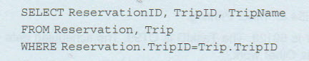

There are a few problems with the SQL code. First, the table where the Trip ID is located must be specified in the “SELECT” section of the query because the Trip ID field is located in both tables specified in the “FROM” section of the query. The next problem is that there is no semicolon at the end of the section in the query. The SQL code with corrections should look as follows:

SELECT ReservationID, Trip.TripID, TripName

FROM Reservation, Trip

WHERE Reservation.TripID = Trip.TripID;